**Launch Jenkins and explore creating projects and users.**

**Step 01:** Verify whether Jenkins is already installed or not

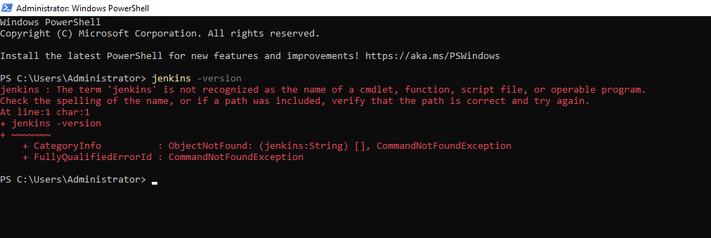

**Step 02:** Installing Jenkins on EC2 instance

2a) Installing Java as it pre requisite to run Jenkins

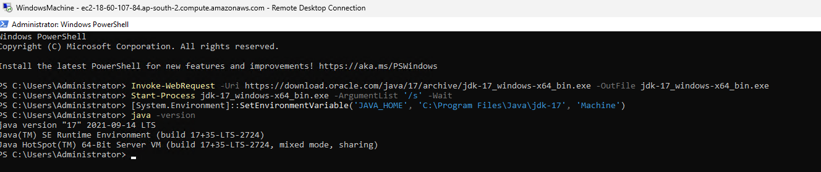

2b) Installing Jenkins

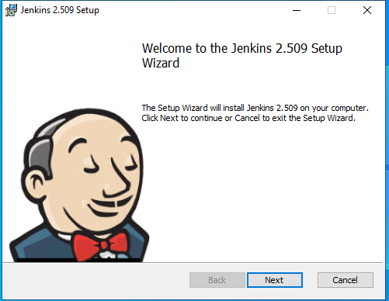

**Step 03:** Start Jenkins Server



**Step 04:** Accessing Jenkins

**Note:** I changed the port number from 8080 to 8081 through Jenkins xml file because port 8080 was already in use by another service on the EC2 Windows machine.

**Step 05:** Creating a new Admin User

**Step 06:** Creating a new Freestyle Project

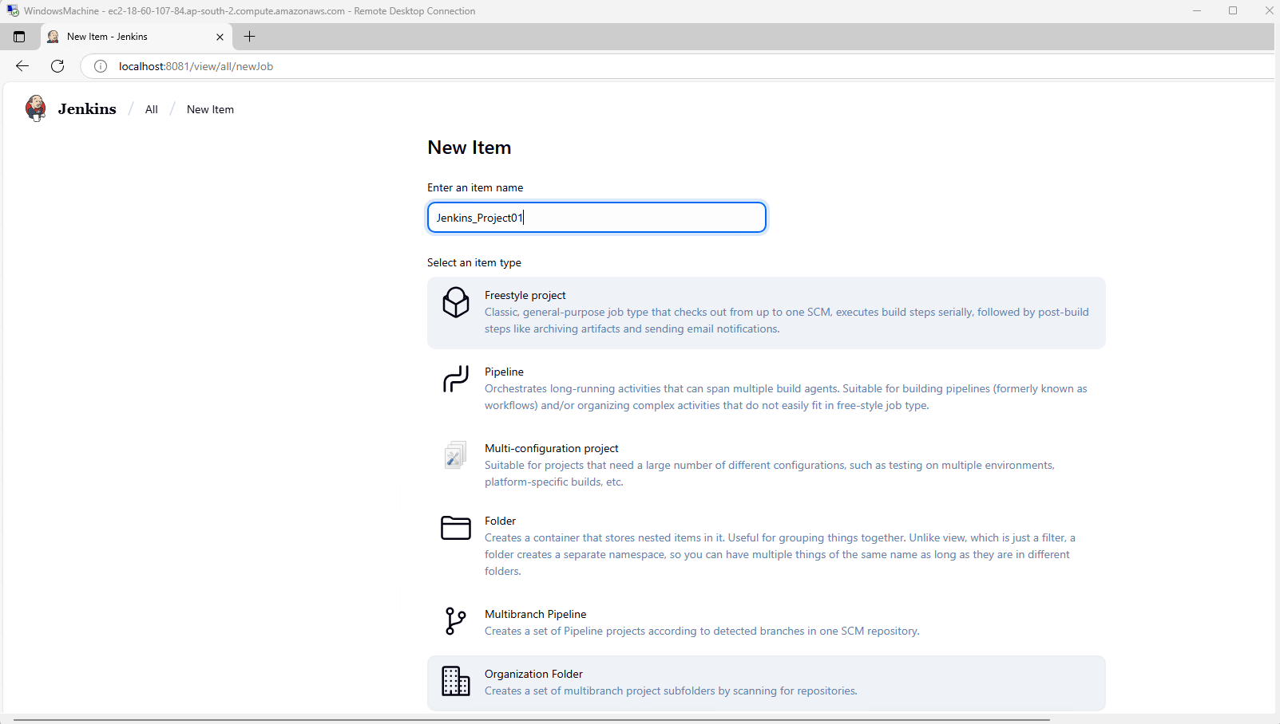

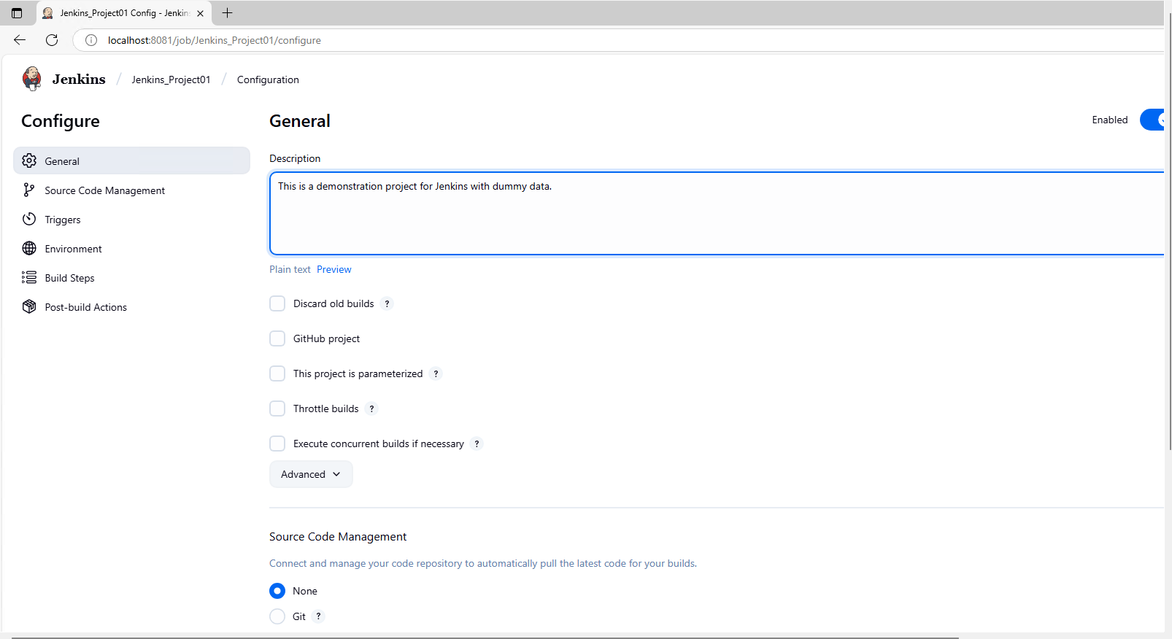

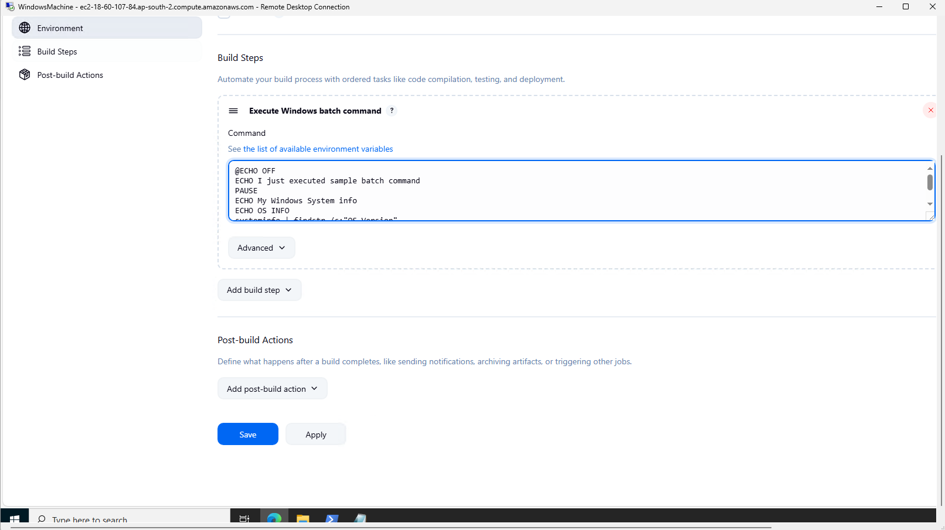

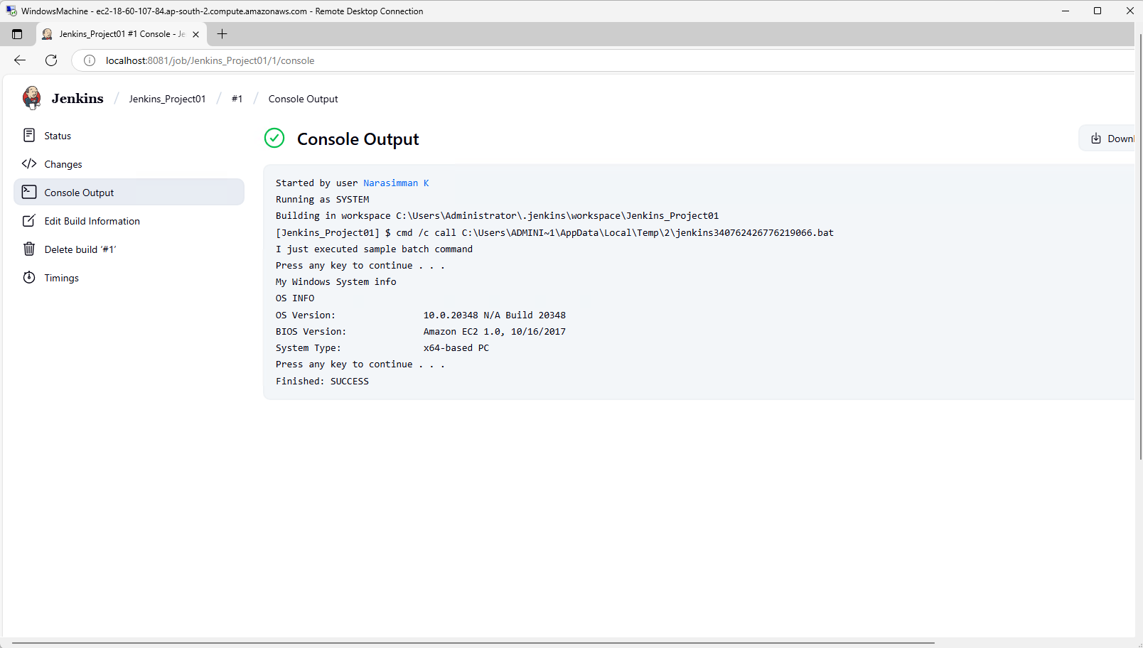

**Step 07:** To create a new user

Logging in with the new user



